CSA1708-ARTIFICIAL INTELLIGENCE
LAB EXPERIMENTS
Program 29 : Prolog Program for Forward Chaining
Aim
To derive new facts repeatedly when their rule conditions are already known.
Algorithm
1. Store initial facts and rules.
2. Check whether a rule's conditions are known facts.
3. Add each new conclusion to the fact database.
4. Repeat until no new facts can be derived.
Program
:- dynamic fact/1.
fact(rain).
rule(wet_grass, [rain]).
rule(slippery_road, [wet_grass]).
forward_chain :-
rule(NewFact, Conditions),
forall(member(C, Conditions), fact(C)),
\+ fact(NewFact),
assertz(fact(NewFact)),
!,
forward_chain.
forward_chain.
Sample Input
?- forward_chain.
?- fact(X).
Program Execution
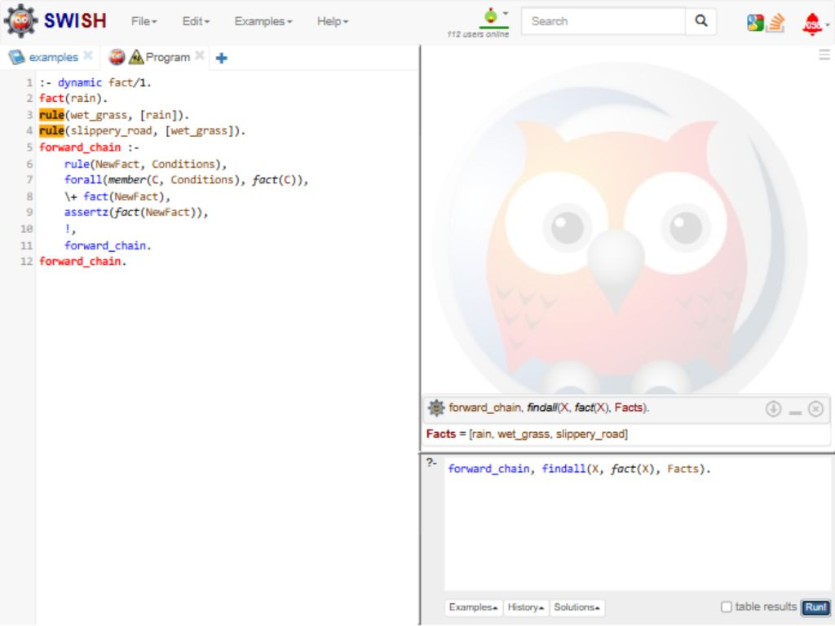
RESULT
Thus, forward chaining derived wet_grass and slippery_road from rain.

